Washems2021!© 

is a standalone pc-based program designed to calculate disallowed losses resulting from the buying and selling of stocks and options. It was written to satisfy the stringent reporting requirement of large financial institutions, hedge funds and major accounting firms and strictly conforms to the rules set forth in Internal Revenue Code Section 1091(a). Based on a user supplied excel file containing all types of market transactions, the program produces an excel workbook containing multiple worksheets detailing all of the information needed to correctly report wash sales, constructive sales, adjusted tax basis dates, reclassified losses, Section 1233 transactions, Straddles, etc. In addition to the detail reports, the workbook reports include numerous summary sections, breakdowns by year, month, etc., and a warnings report listing all realized losses subject to loss if the particular security is reacquired by a specific date. [A Tax Unrealized report is also included but only those open transactions having values in both the Proceeds and Gain/Loss columns will be evaluated and included in the report.]

PREPARING THE INPUT FILE

The Basics

The input file can be either an excel file or a ‘csv’ file. If you choose to use an excel file, it must be the first worksheet in your workbook and conform to the format listed below. If you elect to use a ‘csv’ file, it too must be in the required format. Regardless of the type of input file used, the file should contain one entry per line and, this is very important:

There should be no imbedded commas, double quotes, single quotes or decimal points in any of the fields. All numeric fields (9-12) should contain whole dollars only. And, the date fields 3, 7, and 8 should be in a month/day/year format: mm/dd/yy or mm/dd/yyyy such as: 02/04/04, 02/04/2004, 2/2/04, etc.

Since there's no limit to either the number of transactions or the number of different securities you can process in a single input file, your files can be as large as you like.

Basic Required Fields for Each Line in the Input file

1. Security (stock) Name: up to 80 characters long;
2. Unique Lot Id: unique user defined identifier up to 50 characters in length.
This field is not used in the calculation but is included in the output file;
3. Merger Date: mm/dd/yy or mm/dd/yyyy or blank if not applicable;
4. Option or Stock: “Call”, “Put” or blank for stock;
5. Option Expiration Date: Freeform with a maximum of 10 characters: E.g. 01-
2019, 01/2019, 7-Jan etc. or blank for stock;
(Note: Please use the same format for all options.)
6. Option Strike Price: E.g. 42 ½, not 42.5; blank for stock;
7. Enter Date: date format as above;
8. Exit Date: date format as above or blank if the lot is still open;
9. Number of Shares or Option Lots: maximum of 10 digits;
10. Cost: maximum of 10 digits;
11. Proceeds: maximum of 10 digits; blank if the lot is still open;
12. Gain or Loss: maximum of 12 digits; blank if the lot is still open.

Note: If Fields 9 or 12 are negative, please use a '-' and not parentheses.

Please see the FAQs section at the end for more information.

Additional Fields that can be included in the file

If desired, up to three additional Unique Lot ID fields may be included in the input file. These should be positioned directly after the Unique Lot ID (field #2 above) and directly before the Merger Date (field #3 above). The program will automatically determine if any additional Unique Lot ID fields have been included in the file and reformat the output results accordingly. The first two additional Unique Lot ID fields are not used in any of the calculations but merely provide the user with an additional means of identifying each transaction. The third one is used to control processing sequence of the 1233 report if that option is selected.

Sample Input File

Important Note: Since the program automatically sorts the input file, you can enter your transactions in any order.

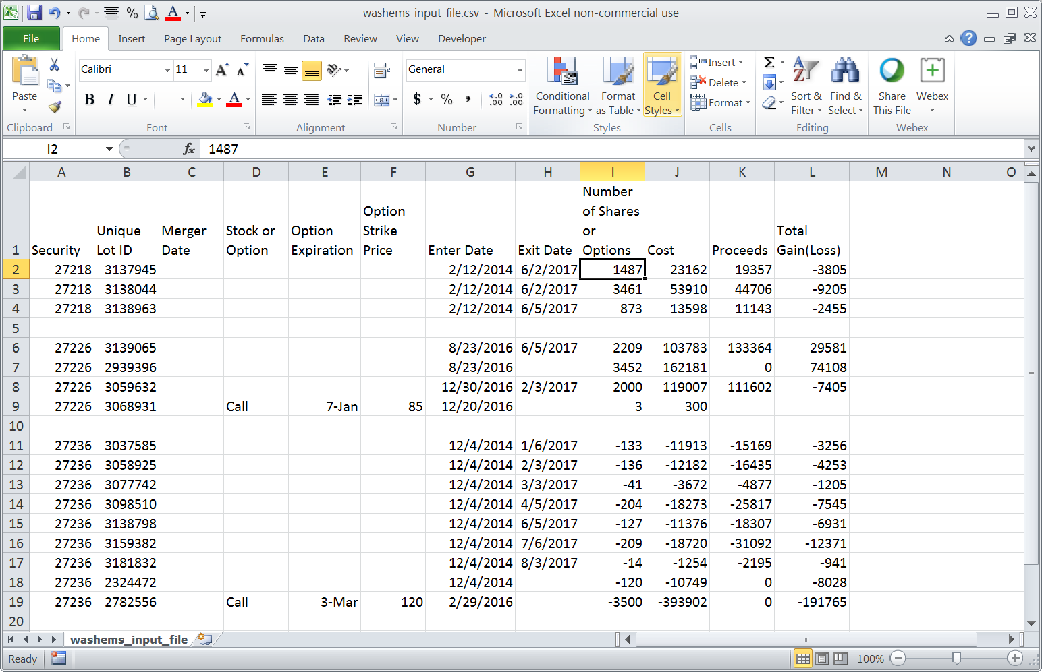
RUNNING THE CALCULATION MODULE

Now that you've created and saved your input file in the correct format, you're ready to calculate your wash sales. The following section describes and explains the job parameters found on the calculation screen. Please note that the program will automatically sort your input file for you in the following sequence: security, close date, open date, unique lot id(s), gain/loss (losses first) and number of shares (shorts first).

Calculation Parameters

- Input File: name and directory (full path) where the input file can be found.
A ‘Browse’ button is provided to help in finding the desired input file.

- * Use Sub Lot Processing *: When a single lot has been used to offset
more than one other lot, sub lot processing will break that lot down into sub components or lots to more accurately show the adjusted basis not only of the shares used for offsetting but also of those shares left over after all of the offsets have been completed.

3. Report Detail Level: Level of detail to show in the report:
(a) ‘All’= shows every security processed from the input file
whether it was used in a wash sale or not;
(b) ‘Scope’ = gives you a choice as to which wash sales to show:
If the total wash sales for a security are less than the
entered Scope Amount, the security is bypassed and does
not appear in the report. A Scope = 1 is thus the same as
selecting the ‘All’ option. If, for example, $500 is entered in
the Scope field, any security having less than $500 in wash
sales will be bypassed and not appear in the output report;

4. Same Date = Same Lot: Select how the program should treat separate
lots that were purchased on the same day for calculation purposes:
(a) ‘Yes’ = all lots purchased on the same day will be combined
and treated as if they are all from the same single lot;
(b) ‘No’ = don’t combine the lots automatically but compare their
prices and, if they’re within a certain percentage of one another,
combine them. The 2 digit percentage field next to the ‘No’ button
holds the variance percentage used in the comparison. For example,
an entry of 5 for 5%, tells the program to compare the purchase
prices of the 2 lots to see if they are within 5% of one another. If
they are, the 2 lots are then combined and considered as one.
Otherwise, if their purchase prices differ by more than 5%, the 2 lots
retain their uniqueness and are treated as separate transactions.
Note: Using a variance of 0 tells the program to treat all lots as
separate transactions regardless of their purchase date.

5. Offset: How the program is to offset Short sales of stock:
(a) ‘Short vs Short’ = can only offset short stocks with short stocks and
nothing else (no long stocks, no calls and no puts);
(b) ‘Short vs Short-Long’ = can only offset short stocks with long stocks,
long calls and short stocks (no puts or short calls);
(c) ‘Short vs Short-Put’ = can only offset short stocks with short stocks and
long puts (no long stocks, no calls and no short puts);

6. Summary Report Breaks: Summary totals to be included in the output file;
[Add the Summary Report to the end of the Wash Sale Detail Report by
checking the box.]

7. Warning Report: Asks the program to include a report in the results file
showing all realized losses that would be lost if a position in the subject
security is obtained prior to the end of the 30 day wash sale period specified
by the As Of Date;

8. Option Conversion:
(a) ‘Convert to Shares’ = convert number of Option Lots into shares (x 100);
(b) ‘Keep as Entered’ = use as entered;

9. Straddle Calculation: Asks the program to include a report in the results file
showing all disallowed losses associated with straddles calculated on one of
two methods: (a) ‘Dollar Amount’ = Disallowed losses are calculated to the
extent of Unrealized Gains; and, (b) ‘Offsetting Shares’ = Disallowed losses are
calculated by matching offsetting shares using the pro-rated Realized Loss vs.
the Unrealized Gain. Additionally, the calculation can be based on all years
present within the input file or just for one specific year;

10. Constructive Sales: Lets the program know if a Constructive Sales report
should be included in the results file and the calculation method to use:
(a) ‘Minimum Gain’ = Results will show the Lowest Gains and the Highest
Locked in Losses;
(b) ‘FIFO Gain Only’ = Results are based on the FIFO matching method for
Gains only;
(c) ‘FIFO’ = Results are based on a straight FIFO method.

11. Processing Sequence: What sequence should be used when processing the
offsetting lots:
(a) ‘Original’ = By the number of days between the sale date of the lot
being offset and the purchase date of the offsetting lot;
For example, a lot purchased 30 days before the sale of the lot being
offset will be used before another lot that was purchased 20 days after
the sale date of the lot being offset. Realized lots will always be
processed before unrealized lots.
(b) ‘Original + Unique Lot ID’ = Same as above + the offsetting lots’ Unique
Lot ID;
When the number of day’s value is the same for 2 or more offsetting
lots, the lots will be processed in Unique Lot ID order without regard
as to whether they are realized or unrealized.
(c) ‘Special’ = (a) Chronologically by the purchase date of the offsetting lot;
and, (b) the offsetting lot Unique Lot ID.
When the purchase date is the same for 2 or more offsetting lots, the
lots will be processed in Unique Lot ID order.

12. 1233 Report: Asks the program to include a report in the results file based on
the holding period adjustment rules of IRS Sections 1233 and 1092 that will
show those gains or losses that can be reclassified from ST to LT or from LT to
ST based on their matchups with other holdings in that same security. The
processing sequences of the matched transactions are controlled by the
selected sorting sequence of:
(a) ‘FIFO’ = Ascending purchase date;
(b) ‘LIFO’ = Descending purchase date;
(c) ‘Special ID’ = User controlled using Unique Lot ID field #4;
(d) ‘Original - Same as Wash Sales’.

Input Screen

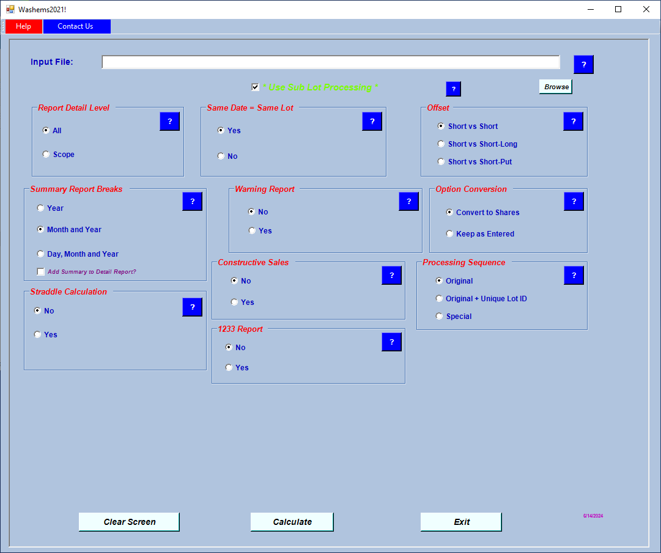

PS: See that little purple date in the right hand corner of the input screen?
That’s the creation date of your current executable so you’ll always be able
to check it against the one shown on the DOWNLOADS page of the website.

Output Results

The output is created as an excel workbook in a subdirectory of the Washems! home directory, “c:\wemspc\ResultFiles” and given a unique name based on the name of the input file and the current run date.

For example, if the input file is called “D:\Files\ABC_Company.xls”, the output file will be created as:
“c:\wemspc\ResultFiles\ABC_Company-xls_mm-dd-yyyy.xlsx”.

Once the calculation process is completed, you’re given the opportunity, as shown in the screen below, to create both a copy of the output file and a csv file of the wash sale results if so desired. These additional processes are completely optional and both fields may be left blank.

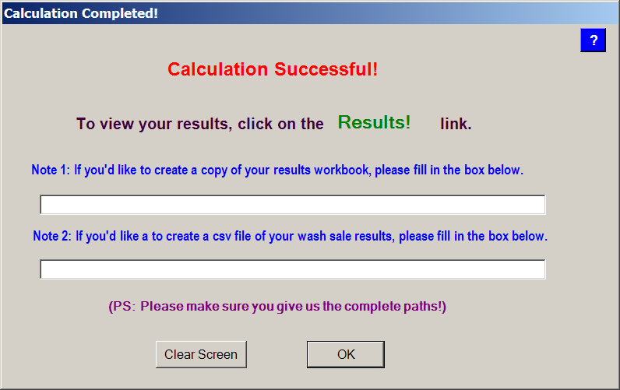

FAQs

1. Day 1, 100 shares of IBM were purchased; Day 2, those 100 shares were sold; then, on Day 3, 100 shares of IBM were repurchased. How would the buy and sell transaction be handled?

The buy and sell would only need to show up on one line not two.
2. Should all long quantities (realized and unrealized) be treated as positive and all short quantities treated as negative?

Yes.
3. Does it matter what sign I put on the cost and proceeds columns for long and
short transactions?

No.

4. Do I need to manually reverse the prior year wash sales?

No. You can run a cumulative wash sale report. By doing it this way, you reverse all of the wash sales booked in prior years that were outstanding at prior year end and then book the cumulative wash sale result from Washems!. When you run your cumulative report include: (1) the realized reports from the prior years; (2) the current year’s realized report; (3) the current year’s unrealized report as of the testing time period; and, (4) the following month’s purchases. (Example: To run cumulative wash sales for 2021 that include all wash sales from 2019, 2020 and 2021, take the realized reports from 2019, 2020 and 2021 and combine them with the unrealized report @ 12/31/2021 and the January 2022 purchases.) To properly reflect the results, automatically reverse all wash sales that were still open at 12/31/2020 and book the Washems! results. In order to assure proper tax character on the reversals, please review the holding period reclassifications included in the report.

For more information, tools (including an input file template you can download), etc., please visit our website at: http://www.washems.com

Harmony Business Solutions, Inc.

Questions? (718) 761-1890 or email us at Results@washems.com

